
Crazy Search V3.3 Instructions

Contents
Version History 1
Introduction 1
System Design 2
New features 2
Bug fix 3s
Screenshots 3
Usage 5
User Requirements 5
Appendix 1: example config.txt file 7
Appendix 2: example results 9

Version History
The Crazy Search program was created in 2016 by Dr Wei Bi at City, University of London. Current Version (v3.3) released 28/11/2017, written by Dr Wei Bi at City, University of London.

Introduction
Crazy Search is a visual search task: a test designed to assess an individual’s ability to actively scan a visual scene for a particular object or feature (the target) among other objects or features (the distractors). The primary dependent variable is Response Time. And Crazy Search systematically manipulates the location of the target, allowing the test to quantify how Response Time varies with eccentricity and/or retinal location. This could be particularly informative with regards individuals with suspected visual field loss.
In practice, the test shows a central image as a reference stimulus, surrounded by a matrix of other images made of multiple distractors and a single target. The user’s task is to find the reference stimulus in the set as quickly as possible.

System Design
The program was created in C# and IDE Visual Studio. The classic software engineering Waterfall model was used in the software design process. The Event-Driven principle is also used.

New features
The test stimuli should only contain odd number of rows and columns. This setup ensures that that reference stimuli are displayed in the centre of the screen and aligned with the rows & columns of the test stimuli.
New features
- There are 2 different modes:
  - Completely random: reference and test stimuli are generated completely randomly.
  - Fix random: reference and test stimuli are generated in a random algorithm with a controllable ‘test series’ seed. When the seed and all other parameters are set the same. The stimuli will be the same but are presented in a random order. This is useful when one wants to compare performance between participants;
If one wants to compare performance within a participant, you can change the number of ‘test series’ (eg. Use 1, 2, 3 ….) to have different tests. Or you can simply use the other complete random mode.
- Eccentricity is now calculated and results are saved in the autosave excel file.
- A pause button ‘SPACE KEY’ is added. Press it during the test will pause the test.
- A resume button ‘ENTER KEY’ is added. Press it when the test is paused will resume the test and the stimulus paused will be re-tested.
- An exit button ‘ESC KEY’ is added. Press it during the test will force the test to stop and exit. However, results tested will be save in the auto-save-excel file in the result/autosave folder.
- The number of rows & columns of the test stimuli can be customized. But they have to be odd numbers.
- The size of the stimulus can be customized.
- The number of repetitions for each test location can be customized.
- The results are saved in an excel file with trial number, location tested, right/wrong responses, images showed, and reaction times.
- Screen resolution can be adjusted. This will affect number of test stimuli displayed.
- The number of test stimuli is calculated based on the row number and column number.
- A config.txt file is added to allow testers to adjust options like: screen resolution, row/column numbers and options showed above.
- You can use mouse to simulate ‘touch’ or use the test in a non-touchable monitor, simply by setting the ‘display cursor’ to ‘yes’.
- You can delete the images unwanted in the my_image_folder.

Notes:
- If the row number and column number is set to a big number, say 21 rows by 35 columns. Then the test becomes slow as it takes time to load images. This can be optimized in the codes, but the easy way is to use a more powerful computer (large memory, SSD, with good CPU).
- Options like screen resolution is only adjusted when you change to a different monitor. The classic option is 1920 x 1080.
- Location is specified with keyword ‘Location X: Y’ where X specifies the location and Y specifies repetition number. If a location is not explicitly specified, it will be tested only once. If you do not want to test that location, you can explicitly set it to 0.
- Total number of images is 2400 and they are located in ‘my_image_folder’. You can delete the images unwanted. But you have to keep the number of images >= row number x column number.

Bug fix
- [fixed] - Stimulus appears multiple times (not unique). The bug only appeared when the location repetition feature was added.

Screenshots
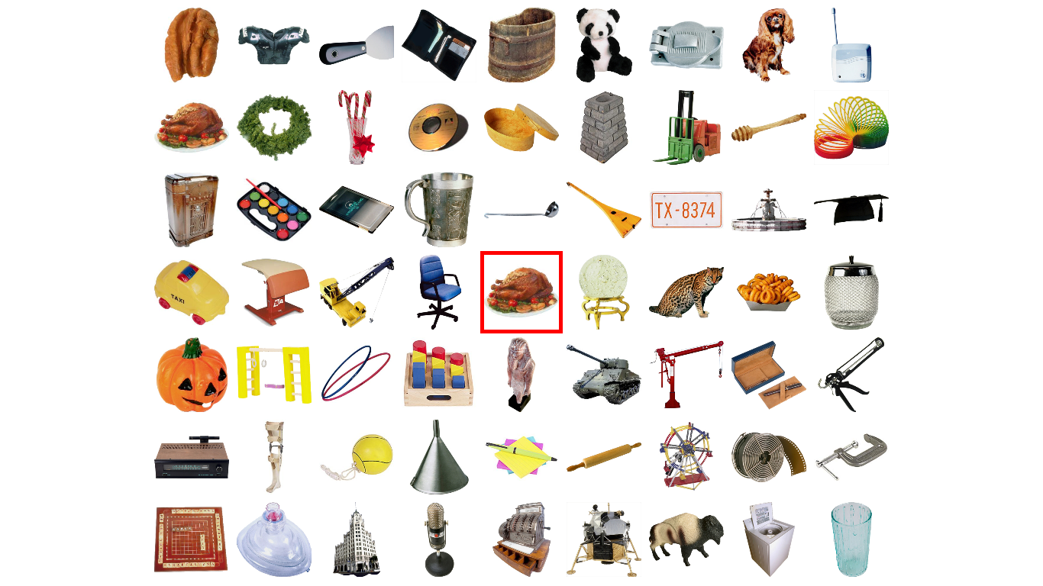
(classic setup) A test with 7 rows by 9 columns images.

The following shows some extreme cases.
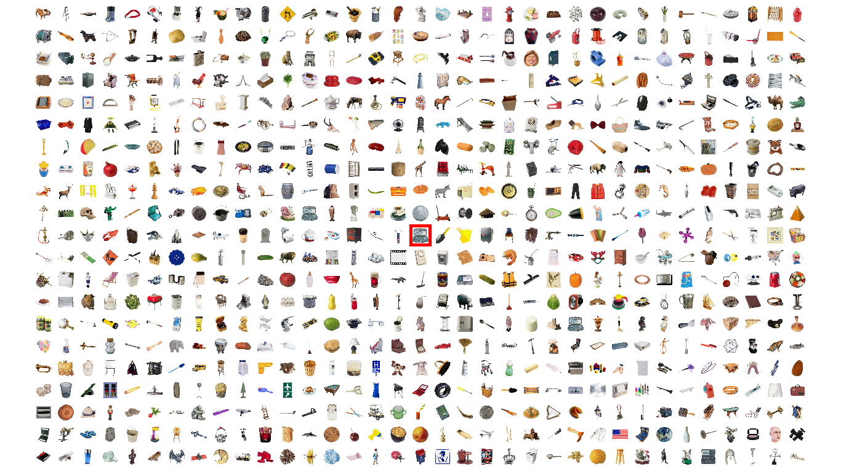
A test with 21 rows by 35 columns images

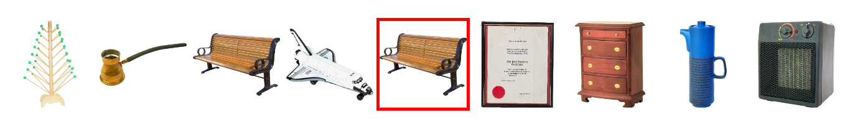
A test with 1 row by 9 columns.

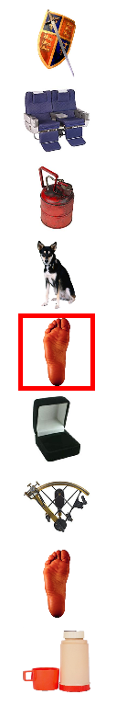
A test with 9 rows by 1 column.

Usage
- Edit options in the config.txt file. (make sure row & column number are odd numbers)
- Double click the crazy_search.exe file to run the test.
- Result will be displayed on the screen in the end of each test. Detailed results will be automatically saved in the result/autosave folder.
- Press ‘Space’ key to pause the test.
- Press ‘Enter’ key to resume the test.
- Press ‘ESC’ key to force exit the test.

User Requirements
- Hardware:

Large touchable screen to cover ±30º of the visual field and maintain comfortable reachable distance for the subject (~50 cm). See figure 1. Edges effect?

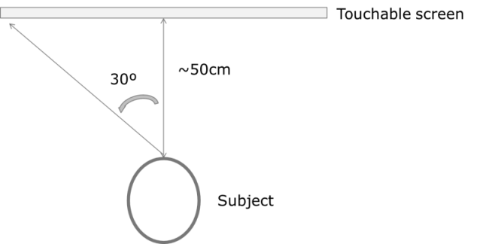

Figure 1. Experimental setup
- Software:

Object identification in the center of the screen (it helps to guarantee central fixation before the test starts)
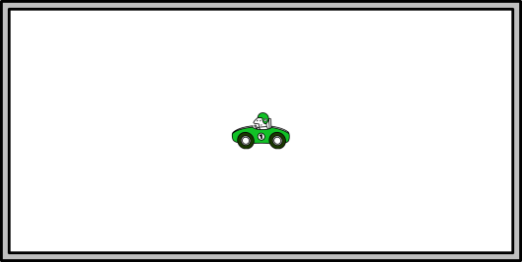

- Customizable number of items in search matrix
- Ability to specificity how many times each element in the search matrix is targeted/tested
- Ability to manually specify the random seed in the config. (i.e., the ability to keep the test sequence the same, or to vary it)
- Pause option: Esc=> break the program; p => pause the program (redo the last trial)


Add parameters to control the test:
- Outputs:
- Time for the response
- Accuracy of the response (correct/incorrect)

Appendix 1: example config.txt file
//: this is a comment
//: do not change the string before colon :
//: you can customise integer values after : but these have to be integer values

//: result is auto saved in the result fold in the format of
//: autosave_XXXX_year-month-day_hour-minute-second.csv

//: To pause the test, press 'SPACE' key on the keyboard
//: To resume the test, press 'ENTER' key on the keyboard

//: Please make sure you use 100% zoom. Do not change the scale, because it affects the eccentricity calculation.

name: Crazy Search v3.0

//: [param]
//: test can have 3 modes: complete random "cr", or fix random "fr"
test mode: cr

//: [param]
//: when test mode = fix random "fr", test can have different series (n>=0).
//: Each serial (eg series = 1) has same stimuli but they are presented in different orders.
//: So that you can compare results between different participants.
//: If you want to compare performance within participants, you can compare results when series = 1, 2, 3 etc.. or simply use "complete random" mode.
test series: 1

//: [param]
//: number of rows or columns in a screen
//: have to be odd rows and odd columns, because centre image is reference stimulus
number of rows: 3
number of columns: 3

//: [param]
//: change the screen resolution according to your screen specifications
screen width: 1920
screen height: 1080

//: [param]
//: Screen dot pitch, ie: distance between two adjacent points on the physical screen
//: This is used to calculate 'eccentricity'.
//: unit is mm
dot pitch: 0.28

//: [param]
//: participant distance to the physical screen
//: This is used to calculate 'eccentricity'.
//: unit is mm
viewing distance: 500

//: [param]
//: display cursor? if yes, then you can simulate/test the test on a non-touch-monitor
display cursor: Yes

//: [param]
//: locations and repeated number for the location.
//: If a location is not explicitely specified, it uses default value, which is 1.
//: Total number of locations = 'number of rows' x 'number of columns'
//: centre location is where the reference stim locates.
//: location starts from 0. it is the topleft stimulus on the screen.

//: you can delete the individual location rows
//: you can also explicitly set an individual location to 0 or someother number

//: If you prefer to use row number and column number for locations, you can
//: convert them, simply use
//: row number = location/number of columns; (the integer part)
//: col number = location - row number * number of columns;

//: So it will not be tested even you explicitely set a value for it

//: [param]
location 0: 0
location 1: 0
location 3: 1
location 4: 2
location 5: 2

Appendix 2: example results
Rand Type | trial num | correctResponses? | displayed image | reactionTime(s) | stimChosen | locationTouched | targetLocation(x=result-(colNum*y); y = result/imgColNum ) | eccentricity.x | eccentricity.y
Fix Random : test 0 | 5 | TRUE | womanpants.jpg | 0.793 | womanpants.jpg | 7 | 7 | 0 | 11
Fix Random : test 0 | 3 | TRUE | Aancientstat4.jpg | 0.446 | Aancientstat4.jpg | 5 | 5 | 11 | 0
Fix Random : test 0 | 0 | TRUE | 22875384.thl.jpg | 0.646 | 22875384.thl.jpg | 2 | 2 | 11 | -11
Fix Random : test 0 | 4 | TRUE | moto.jpg | 0.892 | moto.jpg | 6 | 6 | -11 | 11
Fix Random : test 0 | 1 | TRUE | APARKBENC.jpg | 0.6 | APARKBENC.jpg | 3 | 3 | -11 | 0
Fix Random : test 0 | 2 | TRUE | bait04.jpg | 0.396 | bait04.jpg | 5 | 5 | 11 | 0
Fix Random : test 0 | 6 | TRUE | Apersonsfoot.jpg | 0.492 | Apersonsfoot.jpg | 8 | 8 | 11 | 11

